

[The Iby and Aladar Fleischman Faculty of Engineering](https://en-engineering.tau.ac.il/node/1450" \o "Go to homepage)

Final project submitted toward the M.Sc. degree

in Industrial Engineering

Evaluating Transportation Models with Mobile Location Traces



By: Ilana Don, 304475163

Supervisor: Dr. Eran Toch and Amit Rechavi

Submission Date: December2017

Contents

1. Introduction 2

2. Literature review 2

2.1. Estimation of O-D Matrices using traffic-counts and survey 2

2.2. Estimation of O-D Matrices using mobile phone data 3

2.3. The Research Question 3

3. Research Methodology 3

3.1. Database Description 3

3.1.1. Mobile Phone Traces 3

3.1.2. Transportation Model 3

3.1.3. Information of the statistical areas 4

3.2. Data Preparation 5

4. Results 6

4.1. Trip length distribution 6

4.2. Heat Map Comparison 7

4.3. Trips flow trends 10

4.4. Model Comparison 10

5. Summary 11

6. References 12

7. Appendices 12

# Introduction

Origin-Destination matrix (O-D matrix) represents the movement between locations or areas by displaying the number of trips going from each origin to each destination.

The O-D matrixes are a key input for planning and analyzing transportation systems. There are many approaches for creating these matrixes. Two popular ones are using surveys and traffic counts. The survey-based estimates an O-D matrix using trip survey data. This approach is often costly to obtain due to direct measurements or interviews [1]. In addition, the estimated matrix may vary between different studies due to the limitation of sample size and randomness [2]. According to the second approach, O-D matrixes are derived using the observed link traffic-counts [1]. These methods use different technologies devices like video cameras and loop detectors in order to get the traffic-counts [1]. This approach is also challenged because of the limited coverage and the high cost of implementation and maintenance of these devises.

Today, the rise in the use and coverage of mobile phones led to a massive increase in the volume of records of where people have been and when they were there. The GPS device which is located in mobile phones provides high resolution geographic positioning. Another possible way to determine the location of a user is by the coordinates of the antenna to which his mobile phone is connected. New studies and applications have begun using location data from mobile phones. For example, Rattenbury et al. (2007) used geo-tagging patterns of photographs in Fliker for automatic extraction of interesting events and places [3]. Another example is the ‘Mobile Landscapes’ application described by Ratti et al. (2006) which used cellular network data to learn the city dynamics and urban movement in Milan [4]. These kinds of studies require researches that want to use location data for estimating the O-D matrixes to establish partnerships with mobile network operators in order to obtain the raw data [4]. Using cellular data have a great potential to provide a larger amount of data in a timely manner while the two traditional approaches are time-consuming [2].

# Literature review

## Estimation of O-D Matrices using traffic-counts and survey

Many methods were derived from the traffic-count approach and from the survey-based approach for estimating the O-D matrix. The O-D matrix estimation is considered as optimization problem where the objective function derives from statistical inference techniques such as Maximal Likelihood (ML) and generalized least-square (GLS). Abrahamsson (1998) represents the transportation system as a network. The transport system consists of a number of directed transport links that are connected to each other at nodes. The nodes can be represented as zones. Abrahamsson suggested a method for using traffic-counts. The assumption is that the count measurements are well developed and the traffic volume is accurately collected. In the work, Abrahamsson estimates an O-D matrix from a subset of links and for a specific period of day. When the estimated matrix is assigned to a transportation network (defined by the complete set of the links) it will reproduce the observed traffic count data. The Traffic volume can be collected in different ways and by using different technologies. One technique is using web cameras as described by Santini (2000). Santini inferred the traffic status using the information collected from multiple cameras in the same network.

## Estimation of O-D Matrices using mobile phone data

The location data can be gathered in several ways, such as GPS data which requires active user participation and permission location-based social networks which contains the location at the time of interaction ('check-in' for example) [7]. Another technique is anonymized Call Detail Records (CDRs) from the cellular network operators [2, 7]. After collecting the CDRs information, the data can be aggregated to create an O-D matrix. For example, Zhang (2017) used this data to derive the cellular probe trajectories and then identify the origin and destinations for the trips [2].

## The Research Question

Can we replace the traditional methods with the mobile location traces method for creating transportation model? The goal of this project is to compare the 'mobile traces' generated from location data retrieved from mobile phone carrier with the 'Transport Model' which was generated from data received from the Ministry of Transport. In this work I will use different approaches to compare the transportation models generated from above-mentioned traditional method with the model generated from mobile traces, and try to answer the research question.

# Research Methodology

## Database Description

Three data sources were used in this project; mobile traces, transportation model and geographical statistical data.

### Mobile Phone Traces

The data was collected during January 2013 by the Israeli cellular network operator and includes 1,215,426 users. There are a total of 36,953,479 records, where each record represents a trip with a starting point location and an end point location.

The locations were given as WGS-84 coordinates and the dataset is anonymous, generating a unique id for each user. The person's id can be found in IMSI field.

|  |  |  |  |  |  |  |  |
| --- | --- | --- | --- | --- | --- | --- | --- |
|  | IMSI | start_date | start_lat | start_long | end_date | end_lat | end_long |
| 0 | 28794000865 | 01/01/2013 09:57 | 32.01558 | 34.794727 | 01/01/2013 10:21 | 32.014135 | 34.794279 |
| 1 | 28794000865 | 01/01/2013 12:29 | 32.014 | 34.7943 | 01/01/2013 12:29 | 32.0194 | 34.7647 |
| 2 | 28794000865 | 01/01/2013 22:26 | 32.021105 | 34.769976 | 01/01/2013 22:54 | 32.020167 | 34.769959 |

*Table 1. Example of cellular data*

### Transportation Model

This dataset was provided by the Ministry of Transport and contains 3,462,589 records of trips which occurred in 2012. Similar to cellular data, the records are also anonymous containing 478,591 users. The locations were grouped in Traffic Analysis Zones (TAZ) which represents a geographical area. The TAZ description table defines the TAZ area in sq. km (see some statistics in Table 2.1.) and center's locations of the TAZs which are given in Israeli Transverse Mercator (ITM) coordinates.

|  |  |
| --- | --- |
| Minimum | 0.01 sq. km |
| Maximum | 4.235 sq. km |
| Mean | 0.473552 sq. km |
| Median | 0.3185 sq. km |

*Table 2.1. TAZ area statistics*

|  |  |  |  |  |  |  |
| --- | --- | --- | --- | --- | --- | --- |
|  | personid | tazh | primctod | tazdpr | tazdsec | secctod |
| 0 | 1105320 | 1104 | 8 | 4102 | 1121 | 14 |
| 1 | 378359 | 1104 | 0 | 0 | 0 | 0 |
| 2 | 1105320 | 1104 | 8 | 2112 | 4323 | 14 |

*Table 2.2. Example of relevant fields from transportation data*

Each record in the model describes a trip consisting of a primary tour and a secondary tour. According to the definitions provided with the dataset, there are three fields containing TAZ id (Table 2.2.); 'tazh' is the TAZ of user's residence, 'tazdrp' is the TAZ of the main destination of the primary tour and 'tazdesc' that defines the TAZ of the main destination of the secondary tour. Hence, the assumption is that we can separate the primary tour and the secondary tour into two independent trips. As a result, 'tazdrp' is considered as the origin of the secondary tour in addition of being the destination of the primary tour.

### Information of the statistical areas

In order to compare the 'Mobile Traces' with the 'Transport Model' the two models need to have the same structure of geographical areas. The locations in the 'Mobile Traces' model are given as WGS-84 coordinates while the locations in the 'Transport Model' are given as TAZ ids. This is the reason to use the data that was provided by the Israel Central Bureau of Statistics (CBS), which divided the map of Israel into 3,071 statistical areas. Each area is represented by a unique id, the polygon of the area that is given in ITM coordinates and a name of town. There are some towns ('TEL-AVIV' for example) which are divided into more than one area. So, some different areas can have the same area name. Another thing that can be noticed is that there are 41 areas with no town name.

|  |  |  |  |
| --- | --- | --- | --- |
| OBJECTID | Shape_Area | Shem_Yis_1 | C:\Users\doni\Downloads\Capture.PNG geometry |
| 2 | 6802525.81 | SHAHAR | POLYGON ((…)) |
| 3 | 444514.97 | TIROSH | POLYGON ((…)) |
| 4 | 5983378.02 | NIR HEN | POLYGON ((…)) |

*Table 3. Example of relevant fields from statistical areas*

*information*

*Fig 1. Display the statistical areas*

## Data Preparation

The transportation model was prepared by merging the two data sets that were merged into one table. This merge was done in order to get the locations of the TAZs. Each record in the merged table contains the locations coordinates of the origin and destination points. After that, records without the information on the destination location were removed. Finally, 2,292,181 records remained.

In contrast to the transportation data, we are able to find the location coordinates in the cellular data we obtained. We have rounded the latitudes and longitudes coordinates to 5 decimals (representing a single meter) to analyze the locations efficiently.

The next step was converting the WGS-84 coordinates into ITM coordinates in order to match the locations to the statistical areas. Our purpose at this step is to bring the two data sets (mobile traces and the transportation model) to the same structure of geographical areas.

In addition, the value of trip time should have same structure for the comparison. The start-time and the end-time in the transportation data is given as Combined Time Of Day (CTOD). I got the definition of the calculation from the Ministry of Transport (see in appendix 8.1 and 8.2). Due to the fact that the transportation model does not have accurate information for the start-time and end-time, we will calculate the CTOD for each record of the cellular data.

The locations of both models were mapped according to the statistical areas described in section 3.1. We can see in appendix 8.11 that large group of TAZs are mapped to one statistical area which located in a big town for example 'ASHDOD'. In addition, there are statistical areas that single TAZ is mapped to them, for example 'AHI'EZER' which is a small town.

As a result of the mapping process, two new tables were created, where each record in the new tables contains the statistical area's id and name for the origin and for the destination. These are our O-D models where each record represents a trip with origin and destination areas with the CTOD of the trip. The model that was built based on the transportation data will be called 'Transport Model' and the model built based on the cellular data will be called 'Mobile Traces'. We can see in appendix 8.3 and 8.4 some of the records that appear in the models. 'shapeName_from' and 'shapeName_to' are the fields containing the statistical area's name that is matched to the location coordinates. Similarly, 'shapeName_2from' and 'shapeName_2to' are the fields containing the statistical area's name and id.

# Results

In order to compare the Transport Model with the Mobile Traces, four different approaches were used: (1) trip length distribution; (2) heat maps; (3) trips flow trends; and (4) linear regression.

## Trip length distribution

We compare the trip length distribution between the two models. As Table 4 shows, most of the trips in both data sets have a relatively short length, because the median and the mean are very close to the minimum value of the trip's length. In addition, we can see in the trip length distribution graph (Fig 2.) some similarities between the models. In other words, the trend that can be derived from the graph is that the frequency of trips decreases as the distance increases. However, the difference that can be noticed is that the ratio between the short length and long length trips is much larger in 'Mobile Traces' model than in 'Transport Model'. Approximately 35% short trips in 'Mobile Traces' compared to 13% in 'Transport Model'.

|  |  |  |
| --- | --- | --- |
|  | Transport Model | Mobile traces |
| Minimum | 0 | 0 |
| Maximum | 122.93 | 104.29 |
| Mean | 9.94 | 3.93 |
| Median | 4.45 | 1.15 |

*Table 4. Basic statistics for the trip's length (km)*

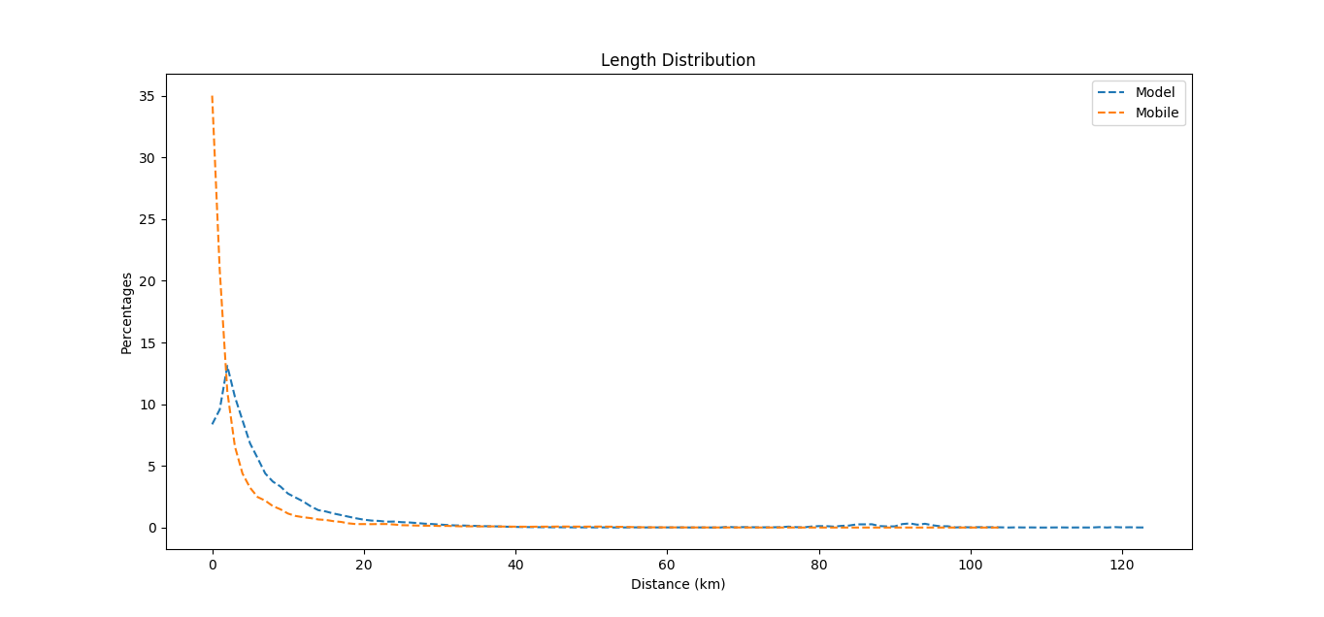

*Fig.2 Length distribution- 'Transport Model' vs. 'Mobile traces'*

Testing the trip length distribution separately for each CTOD, leads to the same conclusion regarding the length distribution trends (see appendix 8.5).

## Heat Map Comparison

The heat maps were produced based on the area's name as the origin and destination of the trips. The comparison was made in two ways. At the first way, all the trips were taken part in the calculation. I count the number of trips for each tuple of origin and destination that occurred in the O-D model. Only the 100 most popular trips can be seen in the heat maps visualization, otherwise the heat maps could not be understood because of the large amount of different trips in the models.

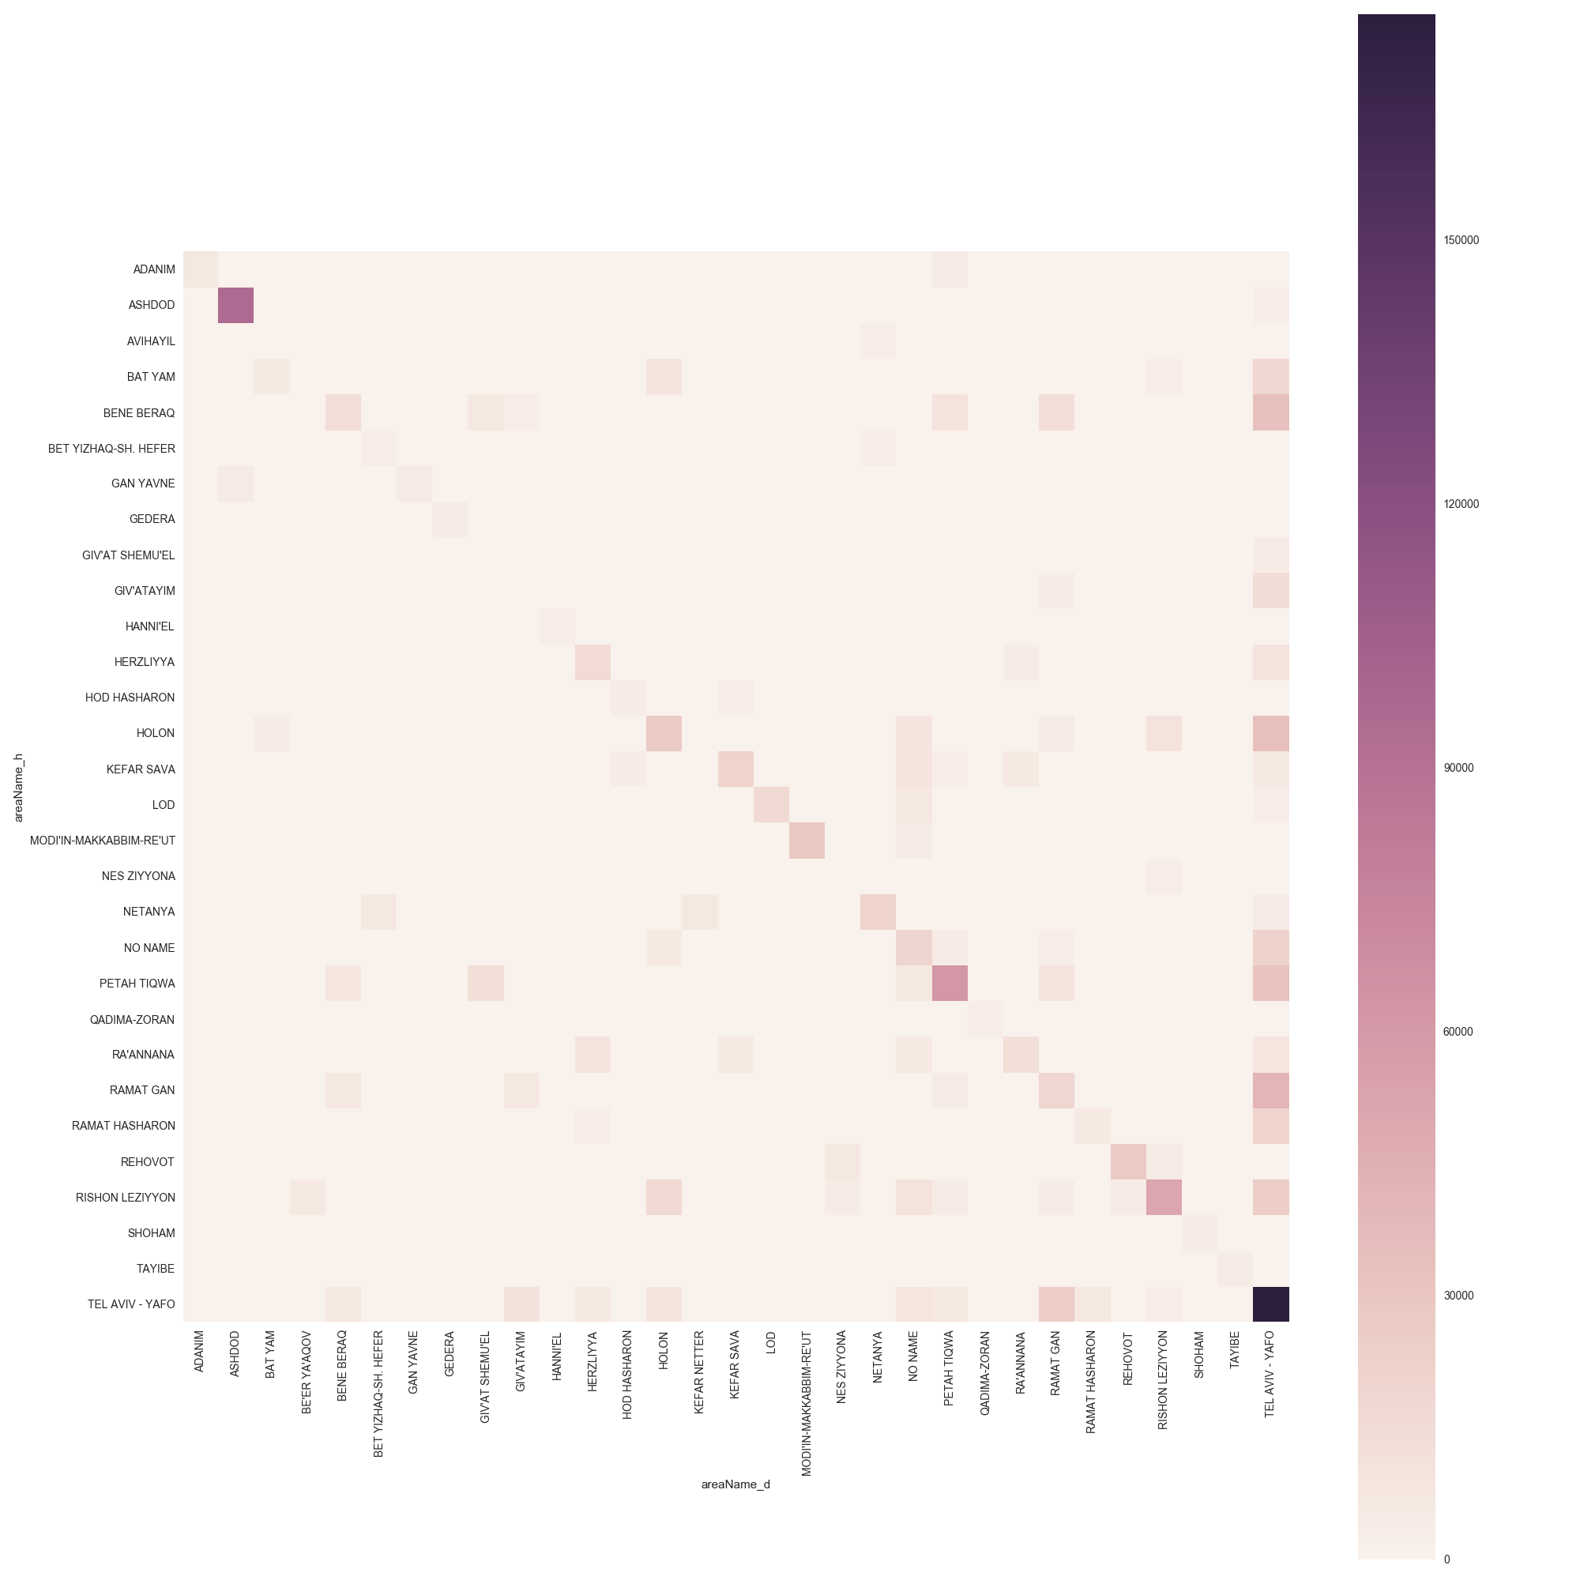

Area name Origin

Area name Destination

*Fig 3.1. Heat maps- 'Transport Model*'

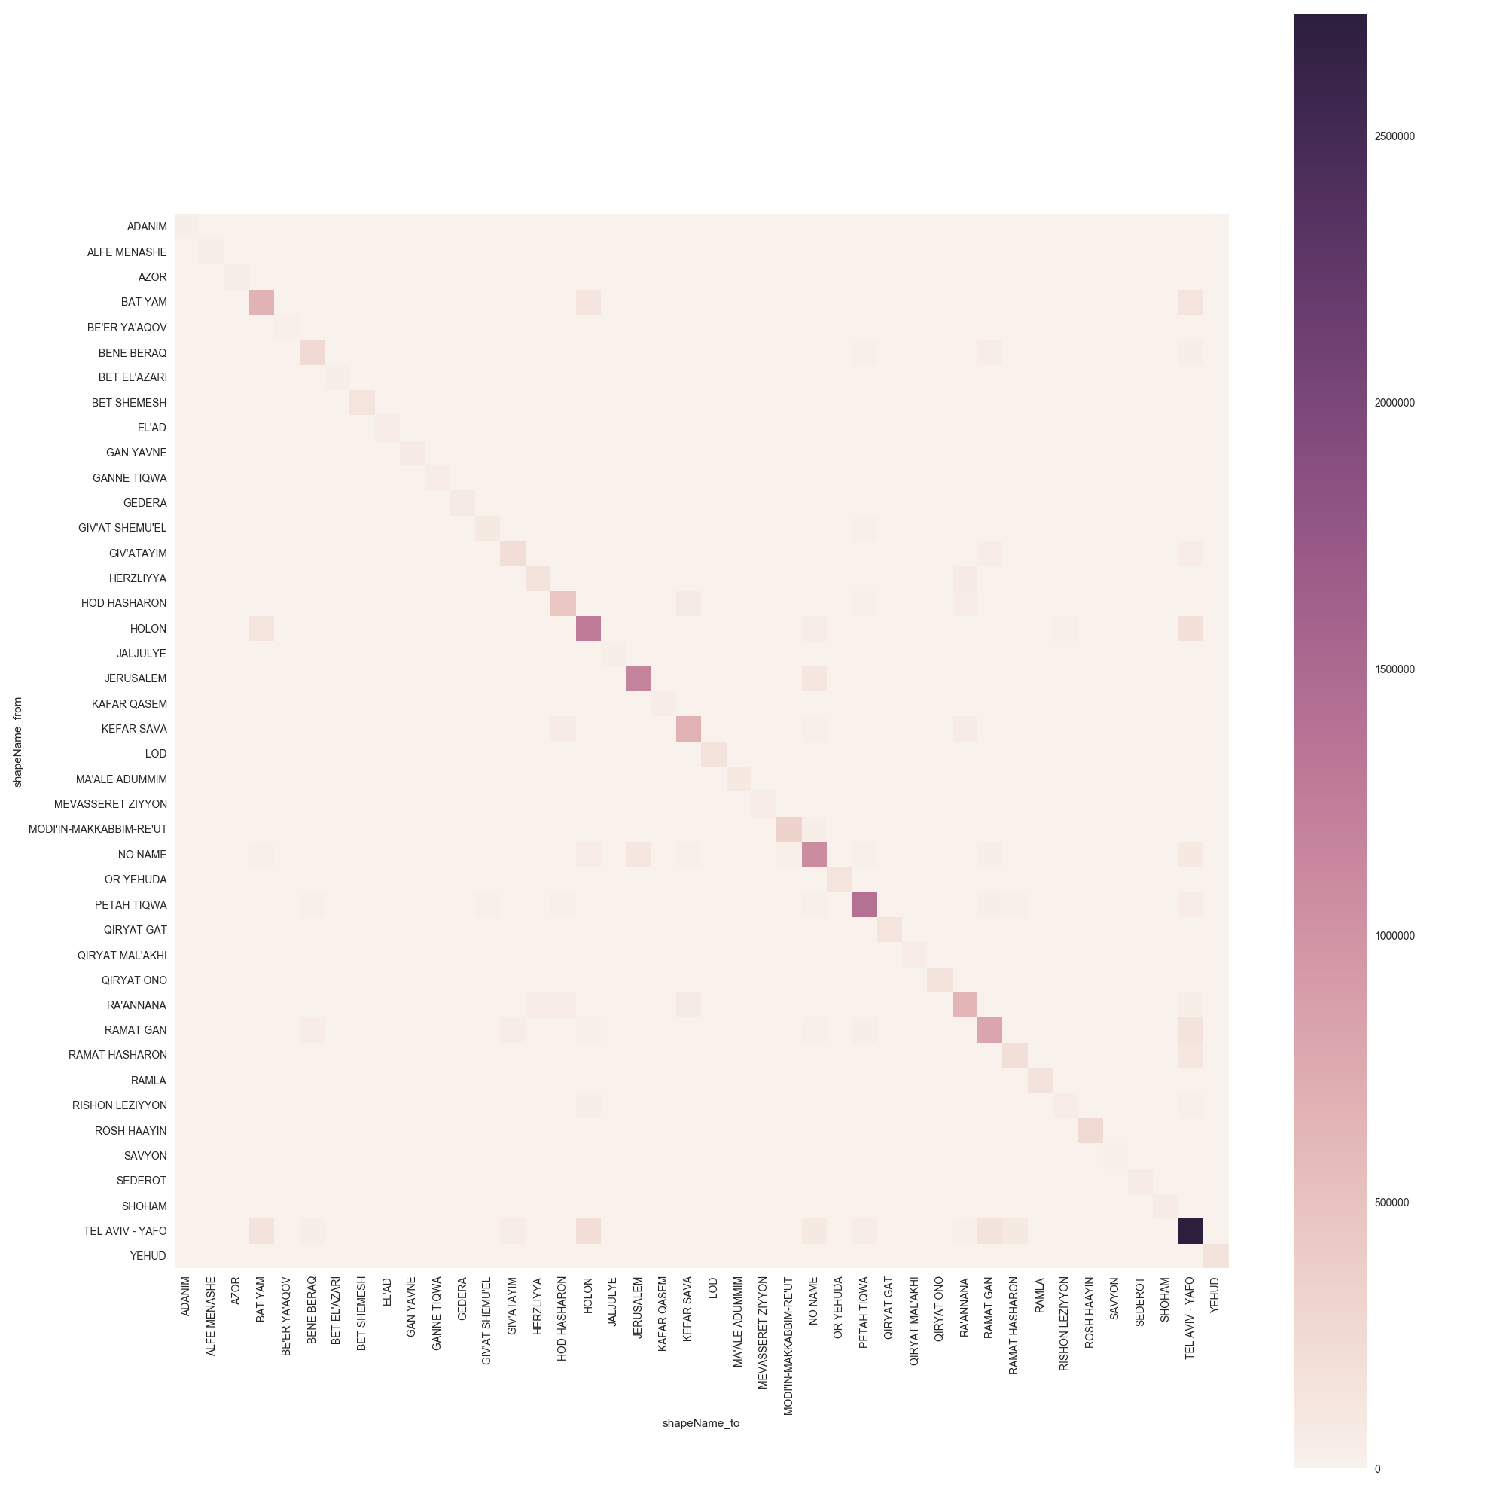

Area name Origin

Area name Destination

*Fig 3.2. Heat maps- 'Mobile Traces'*

In the heat maps, dark colors represent high O-D flow while light colors represent low O-D flow. As shown in Fig.3.1 and in Fig 3.2 (and appendix 8.6), the 'Transport Model's and the 'Mobile traces' flow pattern are quite similar. In both heat maps we can see high O-D flow when the origin and the destination are the same area name (the diagonal). In addition, high O-D flow can be seen when the destination is "TEL AVIV – YAFO". This is more noticeable in the 'Transport Model'. But still exist in both heat maps.

In the second comparison, the trips were separated according to the CTOD of the trip. A heat map was produced for each CTOD (see appendix 8.7). The closer the times of departure and arrival, the diagonal is more pronounced. In other words, when the time of departure and the time of arrival are closer the more organized the heat map is. This makes sense, because the shorter the time of the trip, the greater the chances that the trip begins and ends in the same area. This means that there is a significant high O-D flow in short trips. This pattern can be seen in the heat maps of the 'Mobile traces' and less conspicuously in the heat maps of the 'Transport Model'.

## Trips flow trends

In order to compare the flow trend/pattern of the models, an O-D distribution matrix had been made based on the O-D routes that exist in both models. In other words, only if the [origin, destination] tuple of the trip exists in both of the models it will be taken into account while calculating the matrix. The comparison was made in two ways, one based on the area name, and the other one based on the area id. The sizes of the matrixes produced in the both aspects were pretty big. The size of the matrix based on area name is 5,980 and the one based on the area id is 100,888.

|  |  |  |  |  |  |  |
| --- | --- | --- | --- | --- | --- | --- |
| Shape Name from | Shape Name to | % 'Mobile' | % 'Model' | Count 'Mobile' | Count 'Model' | Diff count |
| TEL AVIV - YAFO | TEL AVIV - YAFO | 8.436 | 8.538 | 2,729,493 | 175,645 | 2,553,848 |
| TEL AVIV - YAFO | HOLON | 0.653 | 0.469 | 211,210 | 9,632 | 201,578 |

*Table 5. An example of the "diff table" based on area name*

|  |  |  |  |  |  |  |
| --- | --- | --- | --- | --- | --- | --- |
| Shape Name from | Shape Name to | % 'Mobile' | % 'Model' | Count 'Mobile' | Count 'Model' | Diff count |
| TEL AVIV – YAFO_2193 | TEL AVIV – YAFO_2193 | 0.147 | 0.034 | 51,172 | 719 | 50,453 |
| HOLON_2476 | HOLON_2440 | 0.000213 | 0.0044 | 74 | 91 | -17 |

*Table 6. Example of the "diff table" based on area id*

Next, I calculated two "diff tables" (examples in Tables 5 and 6). Each record in the "diff tables" represents the difference in the trips count. The "diff count" field is equal to "Count 'Mobile traces'" minus "Count 'Transport Model'". The tables presented in appendix 8.8 displays only 35 records from the table. We can see that the trip from "TEL AVIV – YAFO" to "TEL AVIV – YAFO" is the most popular trip in both models. The next trips located in the top of the tables are trips that occur between big cities that are located in the Central District of Israel. Another thing that can be noticed is that the trips with the highest popularity (can be known according to the percentage field- '% 'Mobile'' and '% 'Model'') are trips in which the origin and the destination are in the same area.

## Model Comparison

Regression analysis was used to determine the relationship between two or more variables by fitting a linear equation to the observed data. In this project I am using the linear regression technique in order to compare the models. The formula for this is where the slop of the line is ; the intercept is ; the depended variable is - in this case the depended variable is the count of trips in 'Transport Model' between two areas; and the independed variable is - in this case is the count of trips in 'Mobile Traces' model between two areas. The comparison was based on different ways; based on the area name, based on the area id and based only on trips inside areas.

was calculate for each regression test. The regression based on the area name (see appendix 8.9) shows a pretty good fit, equal to 0.585 (where the intercept is equal to 165.036105 and the slope is 0.050395).

And for about the regression based on the area id (see appendix 8.10), a low was received which is equal to 0.096. The intercept is 12.561314 and the slope is 0.020064.

Next, I extracted all the trips that the origin and the destinations were not identical from the both models in order to test the regression on the number of trips inside the areas. The model fits with = 0.608 where the intercept = 1132.264842 and the slop is equal to 0.047729 (Fig.4).

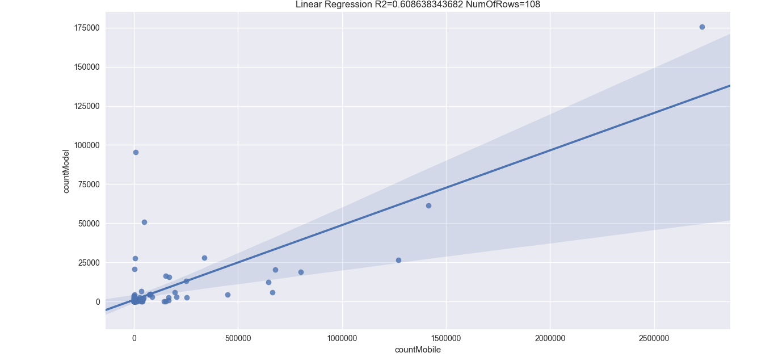

*Fig.4 Regression- 'Transport Model' (Y axis) vs. 'Mobile traces'(X axis)*

# Summary

Four approaches were tested in this project in order to compare the 'Transport Model' with the 'Mobile traces' that were generated from the cellular data and the transportation data.

Comparing by finding trends in length distribution of trips, leads to the conclusion that the models behave quite similarly in some ways. The trend that can be derived is that the frequency of trips decreases as the distance increases. Another thing that can be deduced is that the percentage of short length trips in 'Mobile Traces' is significantly larger than in 'Transport Model'.

There is a similar trend that can be derived from the trips flow trends comparison and from the heat maps. The most popular trip in both models is a trip that both the origin and destination of it is "TEL AVIV – YAFO". In addition, the most popular trips take place between major areas that are located in the 'Central District of Israel'.

In conclusion, we can say that the mobile traces generated from cellular data can be a good base to rely on as an O-D matrix for transportation planning and analyzing according to the value I got, 60.8% of the variance in the values of transport model that can be explained by knowing the value of the mobile traces. As to my research question, it can be concluded that a mobile phone sensing method for creating transportation model can replace the traditional methods. To reach greater accuracy, similar comparisons to those I have done in this work can be done on trips based on the same data set. Namely, the comparison may be done on the same population or in the same time period.

# References

1. Abrahamsson, Torgil. "Estimation of origin-destination matrices using traffic counts-a literature survey." (1998).
2. Zhang, Yi, et al. "Daily OD matrix estimation using cellular probe data." *89th Annual Meeting Transportation Research Board*. Vol. 9. 2010.‏
3. Rattenbury, Tye, Nathaniel Good, and MorNaaman. "Towards automatic extraction of event and place semantics from flickr tags." *Proceedings of the 30th annual international ACM SIGIR conference on Research and development in information retrieval*. ACM, 2007.
4. Ratti, Carlo, et al. "Mobile Landscapes: using location data from cell-phones for urban analysis."‏
5. Santini, Simone. "Analysis of traffic flow in urban areas using web cameras." *Applications of Computer Vision, 2000, Fifth IEEE Workshop on..*IEEE, 2000.‏
6. Jin, Peter J., et al. "Urban travel demand analysis for Austin TX USA using location-based social networking data." *TRB 92nd Annual Meeting Compendium of Papers*. 2013.‏
7. Lin, Ziheng, et al. "Deep Generative Models of Urban Mobility." (2017).

# Appendices

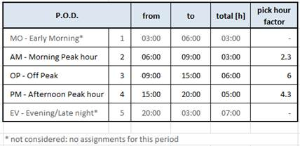

* 1. *Detailed definitions of day periods taken from Ministry of Transport*

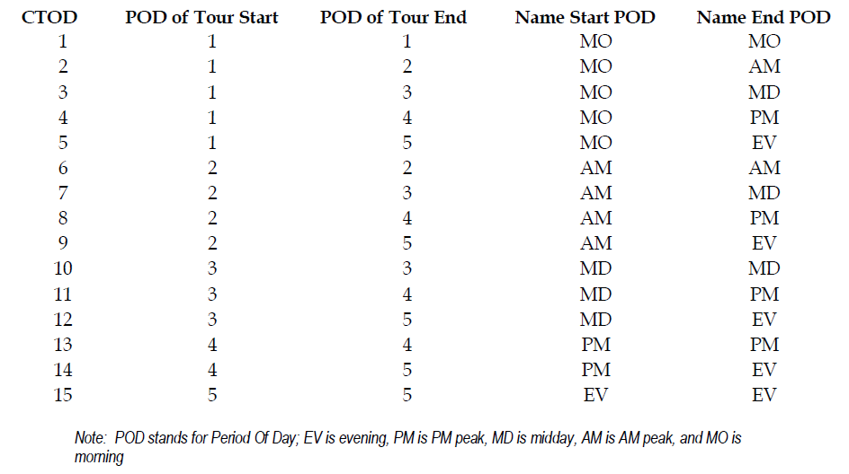

* 1. *Definition of Combined Time of Day (CTOD)*

|  |  |  |  |  |  |
| --- | --- | --- | --- | --- | --- |
|  | tazh | ctod | tazd | latlonO | latlonT |
| 0 | 1104 | 10 | 1124 | (32.14482, 34.79929) | (32.11096, 34.81752) |
| 1 | 1104 | 11 | 1121 | (32.14482, 34.79929) | (32.12185, 34.81455) |
| 2 | 1104 | 13 | 7104 | (32.14482, 34.79929) | (31.91484, 34.80598) |

|  |  |  |  |  |
| --- | --- | --- | --- | --- |
|  | shapeName_from | shapeName_2from | shapeName_to | shapeName_2to |
| 0 | HERZLIYYA | HERZLIYYA_2390 | TEL AVIV - YAFO | TEL AVIV - YAFO_2199 |
| 1 | HERZLIYYA | HERZLIYYA_2390 | TEL AVIV - YAFO | TEL AVIV - YAFO_2195 |
| 2 | HERZLIYYA | HERZLIYYA_2390 | NES ZIYYONA | NES ZIYYONA_2593 |

*8.3. Example of the transport model*

|  |  |  |  |  |  |
| --- | --- | --- | --- | --- | --- |
|  | start_lat | start_long | end_lat | end_long | ctod |
| 0 | 32.18180 | 34.91109 | 32.18127 | 34.91297 | 6 |
| 1 | 32.18220 | 34.90960 | 32.19130 | 34.87120 | 6 |
| 2 | 32.19130 | 34.87120 | 32.18275 | 34.91234 | 13 |
| 3 | 32.17800 | 34.91359 | 32.18148 | 34.91095 | 13 |

|  |  |  |  |  |
| --- | --- | --- | --- | --- |
|  | shapeName_from | shapeName_2from | shapeName_to | shapeName_2to |
| 0 | KEFAR SAVA | KEFAR SAVA_2528 | KEFAR SAVA | KEFAR SAVA_2528 |
| 1 | KEFAR SAVA | KEFAR SAVA_2528 | RA'ANNANA | RA'ANNANA_2889 |
| 2 | RA'ANNANA | RA'ANNANA_2889 | KEFAR SAVA | KEFAR SAVA_2528 |
| 3 | KEFAR SAVA | KEFAR SAVA_2530 | KEFAR SAVA | KEFAR SAVA_2528 |

*8.4. Example of the mobile traces*

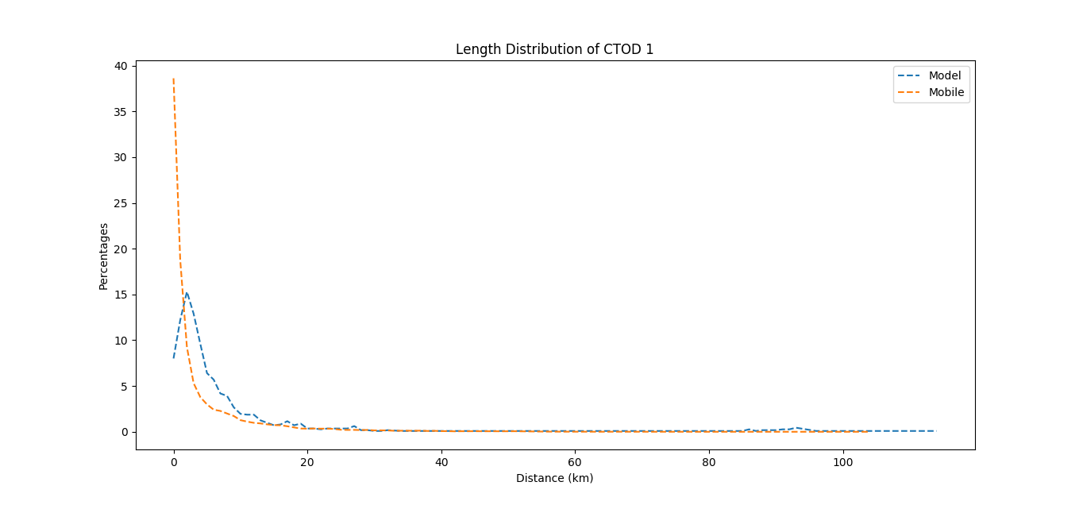

*8.5.1.Length distribution for CTOD 1*

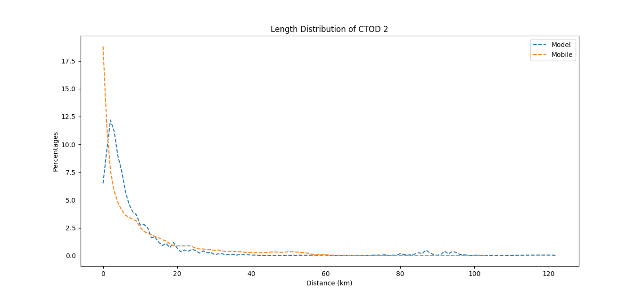

*8.5.2. Length distribution for CTOD 2*

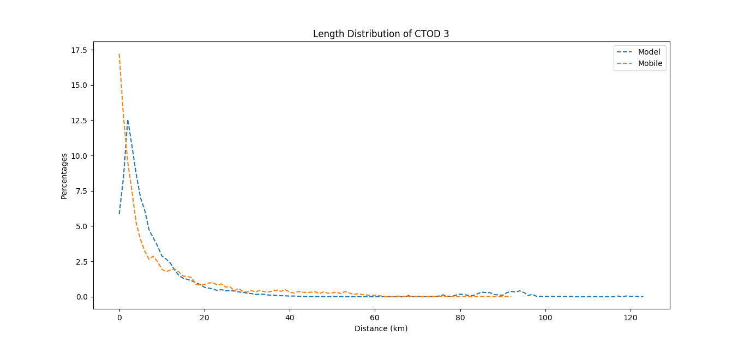

*8.5.3. Length distribution for CTOD 3*

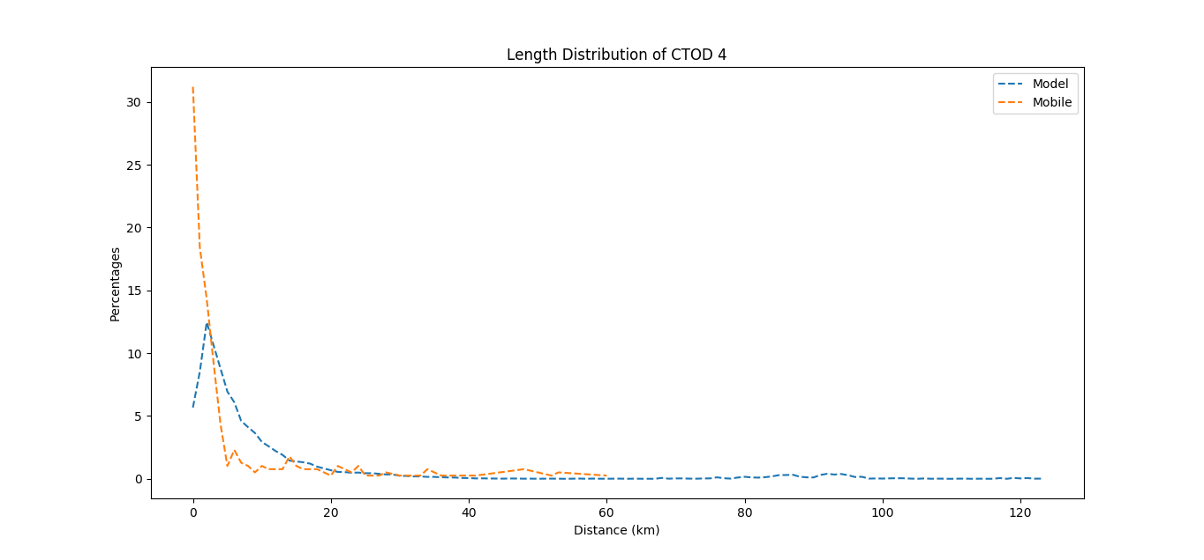

*8.5.4. Length distribution for CTOD 4*

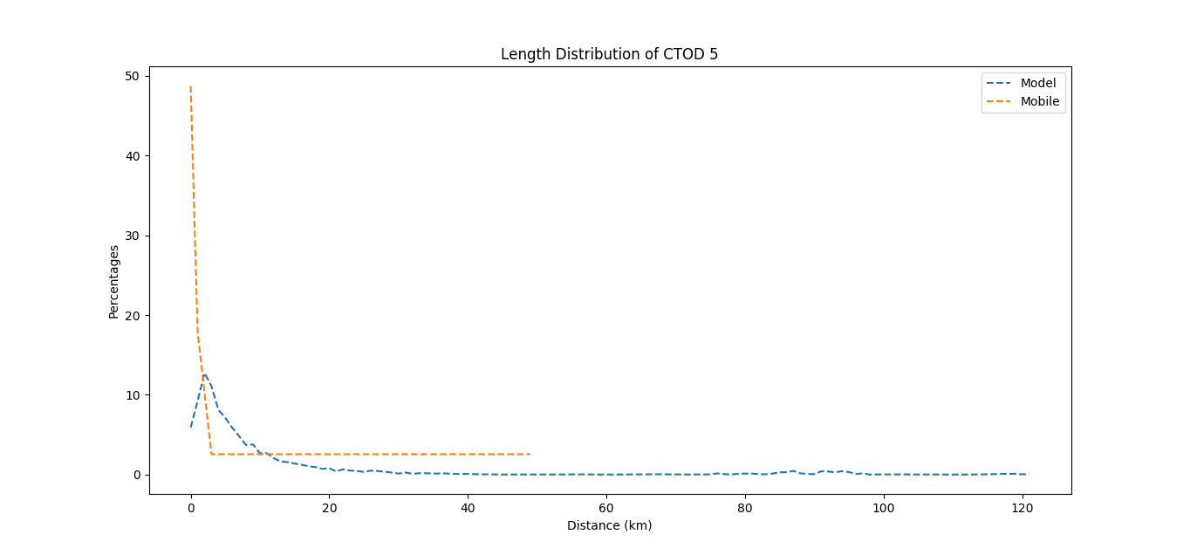

*8.5.5. Length distribution for CTOD 5*

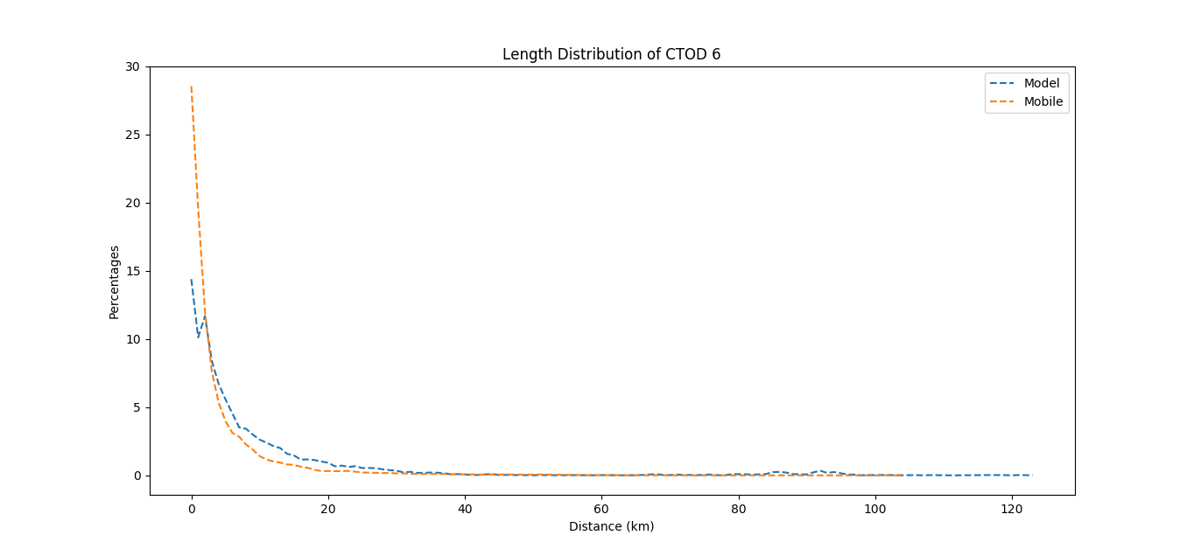

*8.5.6. Length distribution for CTOD 6*

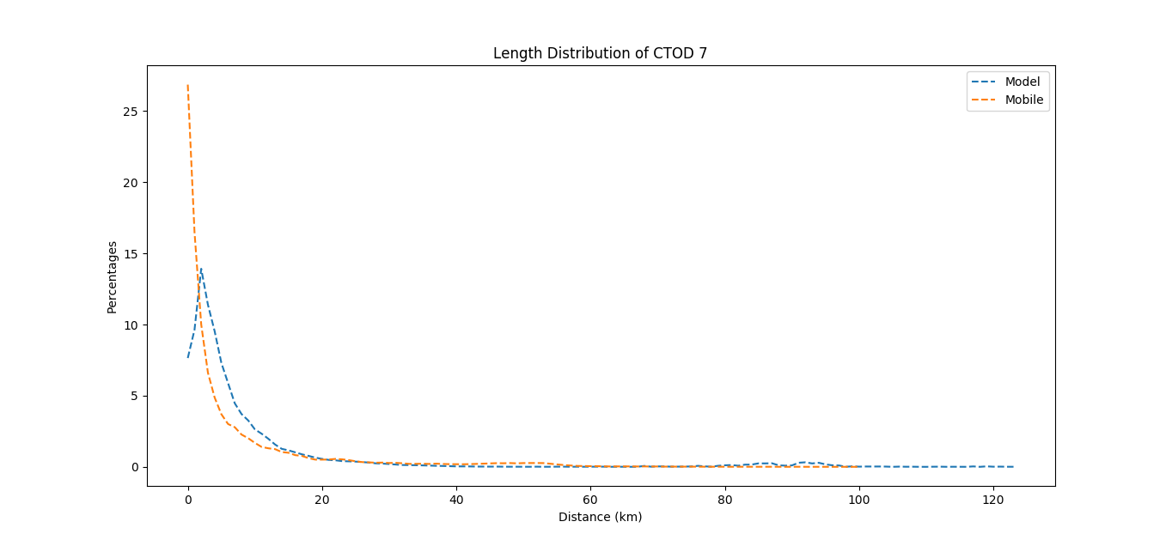

*8.5.7. Length distribution for CTOD 7*

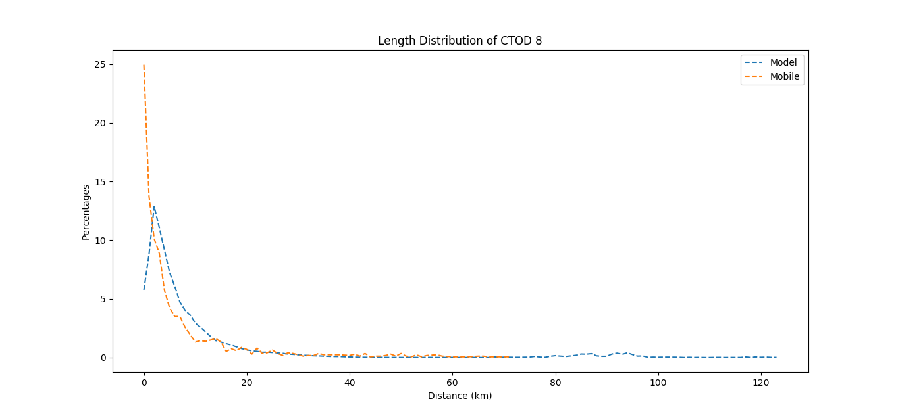

*8.5.8. Length distribution for CTOD 8*

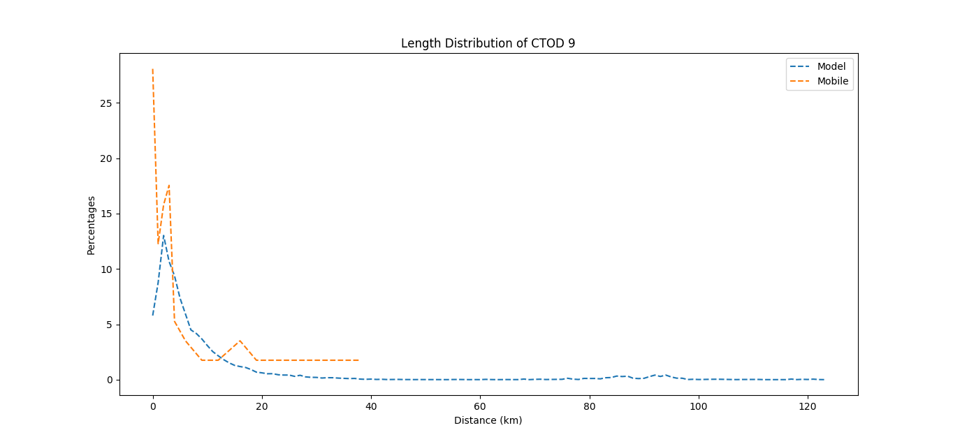

*8.5.9. Length distribution for CTOD 9*

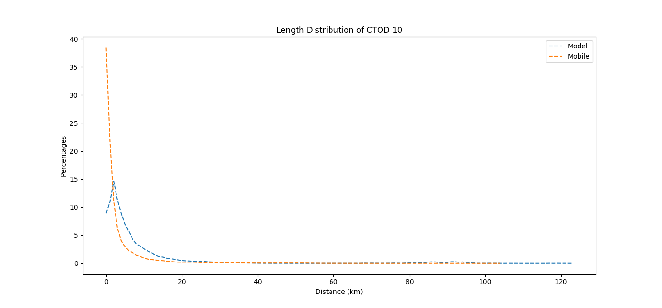

*8.5.10. Length distribution for CTOD 10*

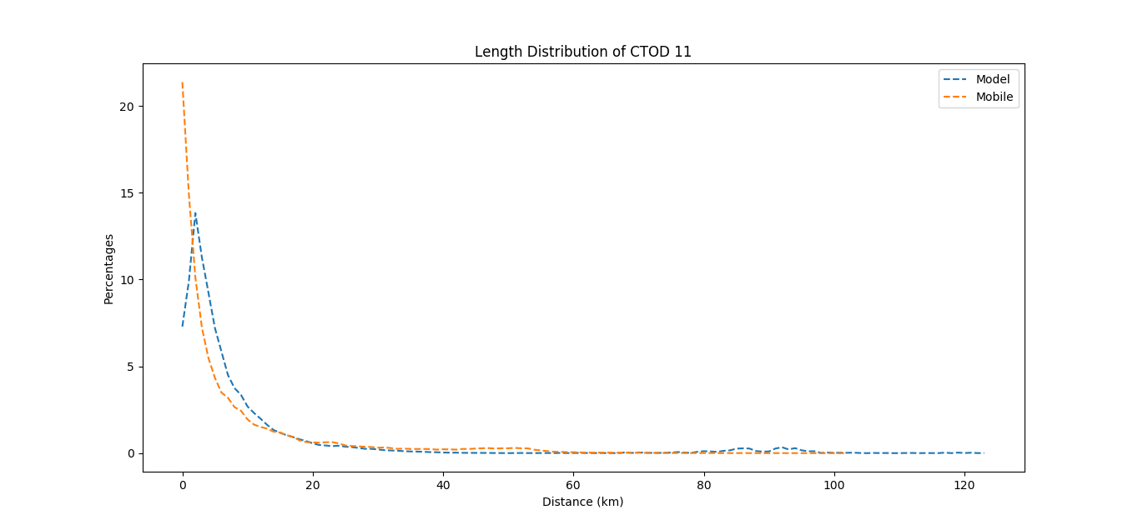

*8.5.11. Length distribution for CTOD 11*

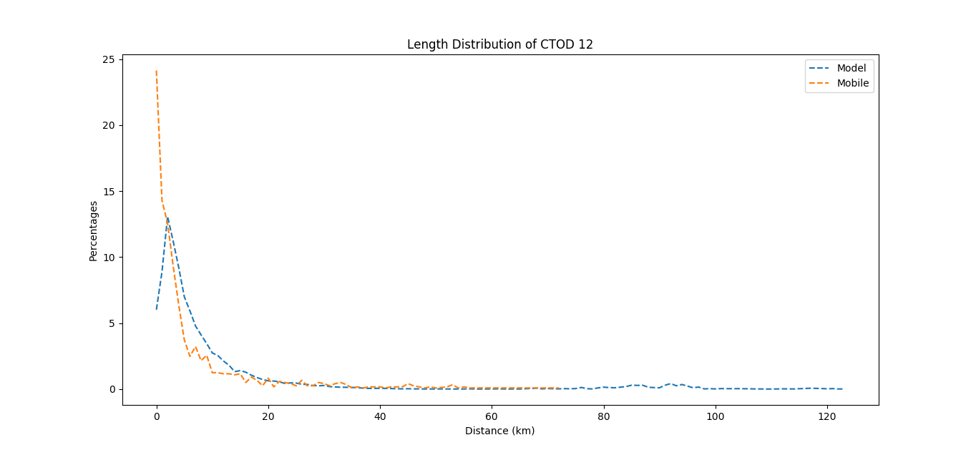

*8.5.12. Length distribution for CTOD 12*

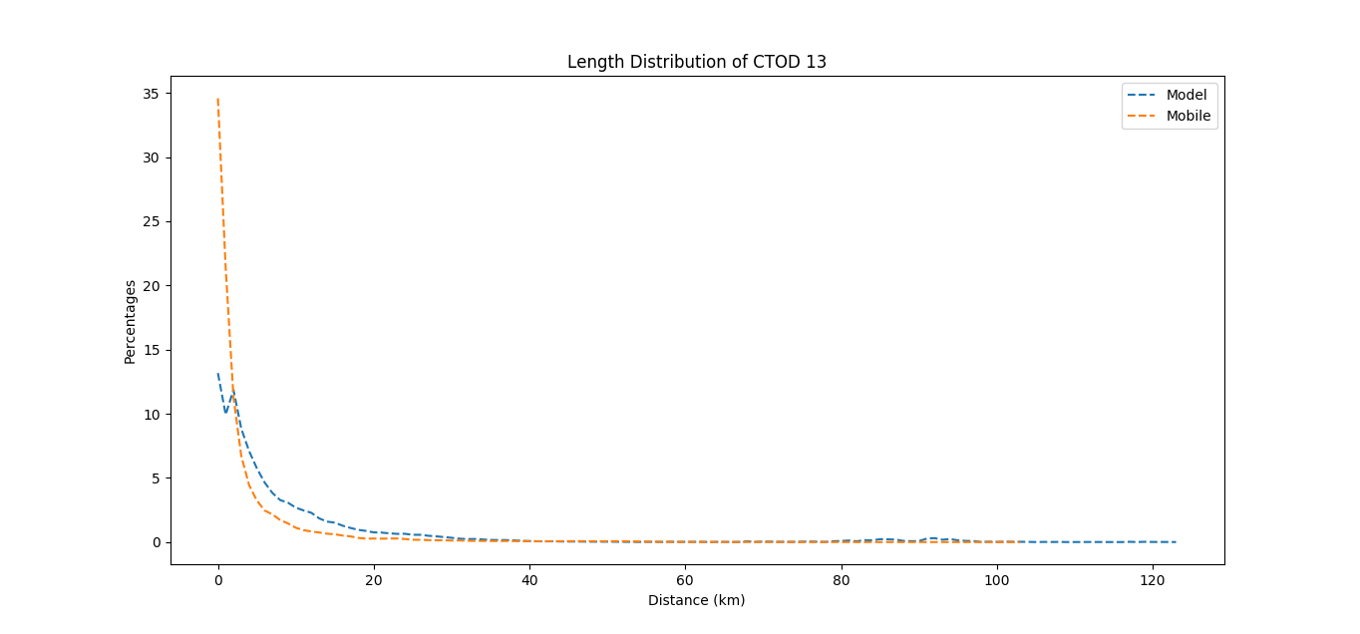

*8.5.13. Length distribution for CTOD 13*

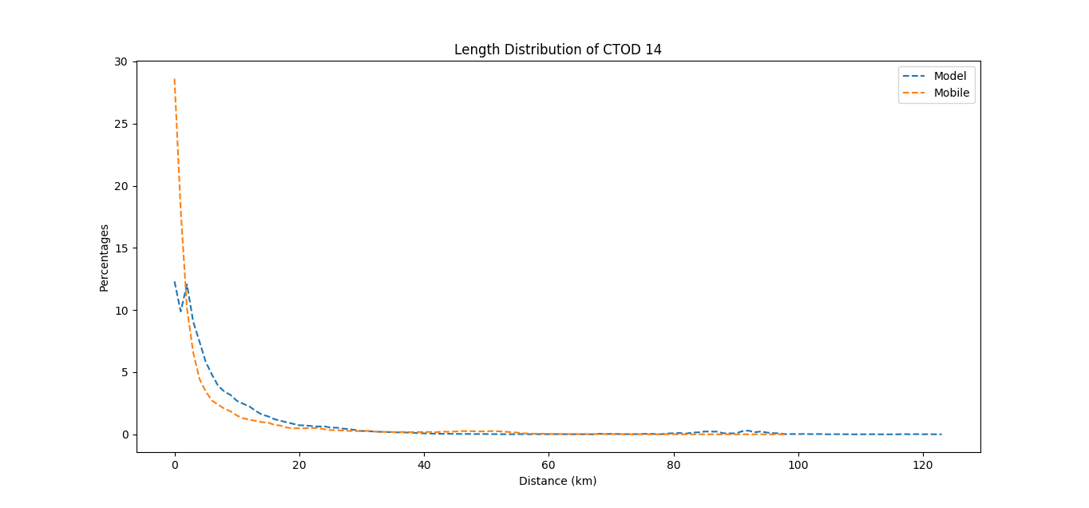

*8.5.14. Length distribution for CTOD 14*

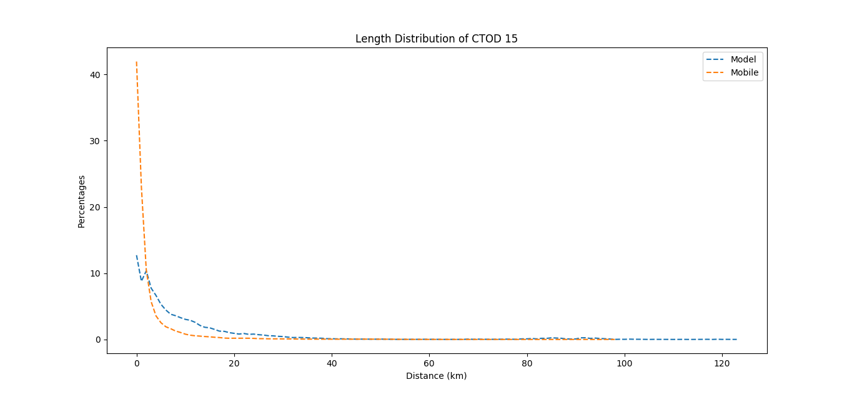

*8.5.15. Length distribution for CTOD 15*

**

*8.6.1. Heat Map-Transport Model*

**

*8.6.2. Heat Map for the mobile traces*

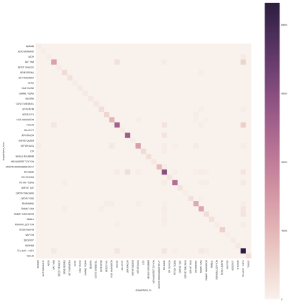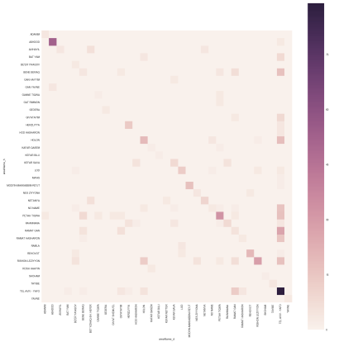

*8.7.1. Heat Map for the transport model (Left) vs. mobile traces for CTOD 1*

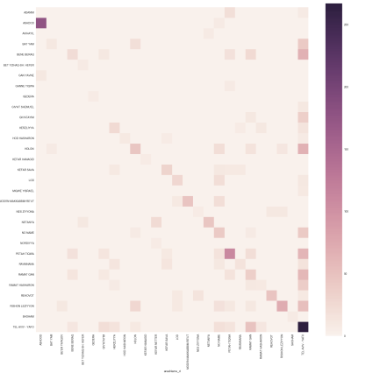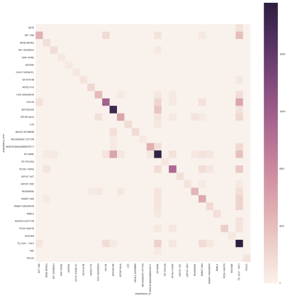

*8.7.2. Heat Map for the transport model (Left) vs. the mobile traces for CTOD 2*

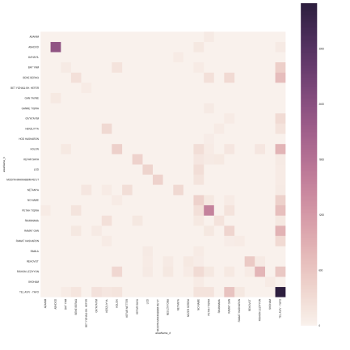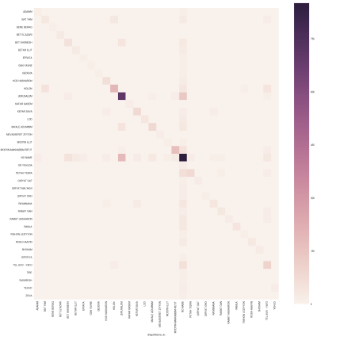

*8.7.3. Heat Map for the transport model (Left) vs. the mobile traces for CTOD 3*

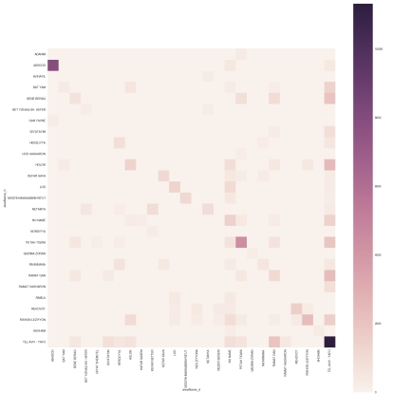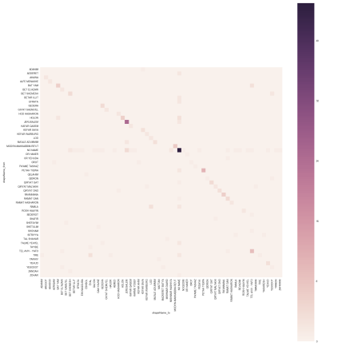

*8.7.4. Heat Map for the transport model (Left) vs. the mobile traces for CTOD 4*

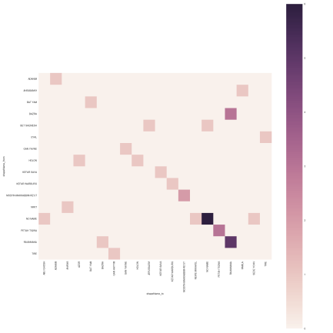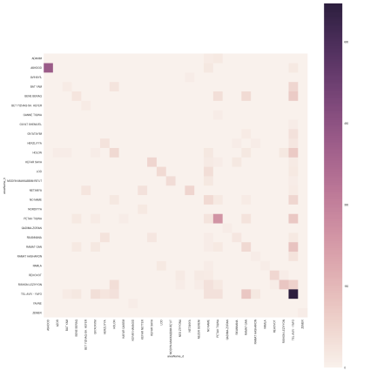

*8.7.5. Heat Map for the transport model (Left) vs. the mobile traces for CTOD 5*

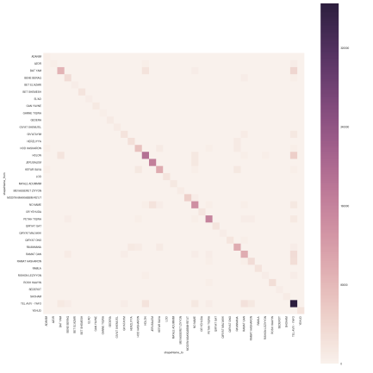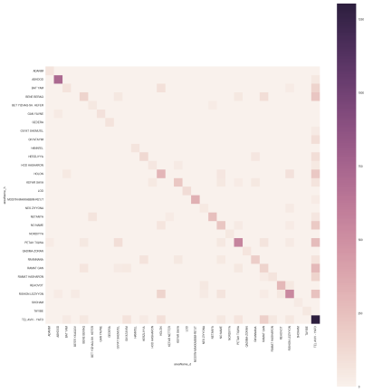

*8.7.6. Heat Map for the transport model (Left) vs. the mobile traces for CTOD 6*

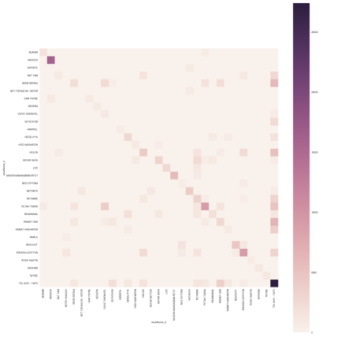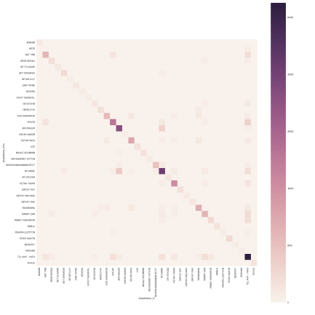

*8.7.7. Heat Map for the transport model (Left) vs. the mobile traces for CTOD 7*

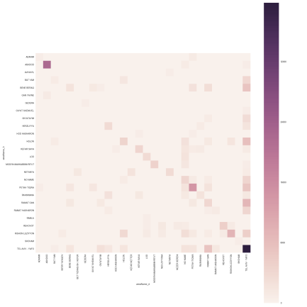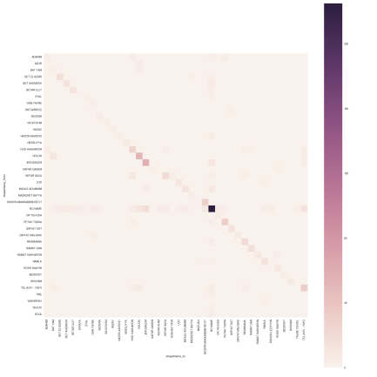

*8.7.8. Heat Map for the transport model (Left) vs. the mobile traces for CTOD 8*

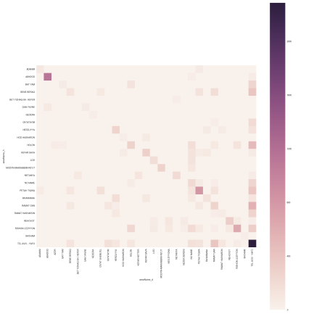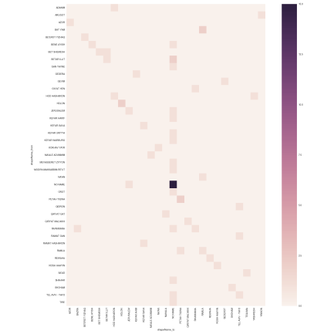

*8.7.9. Heat for the transport model (Left) vs. the mobile traces for CTOD 9*

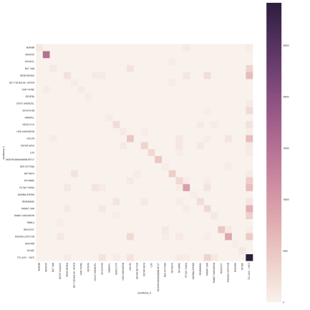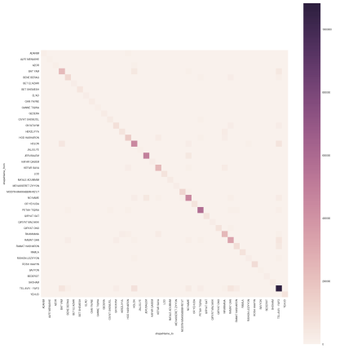

*8.7.10. Heat Map for the transport model (Left) vs. the mobile traces for CTOD 10*

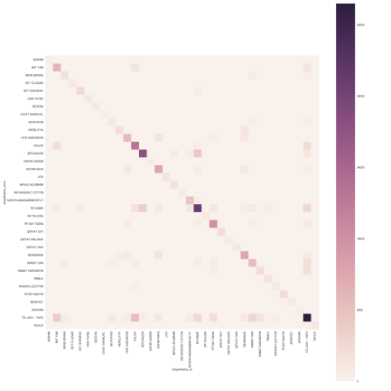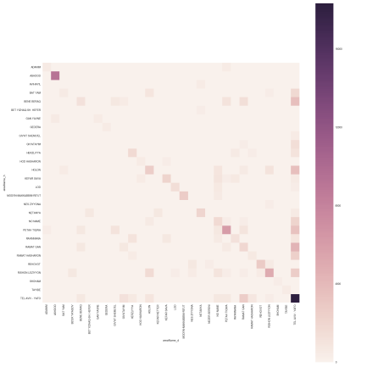

*8.7.11. Heat Map for the transport model (Left) vs. the mobile traces for CTOD 11*

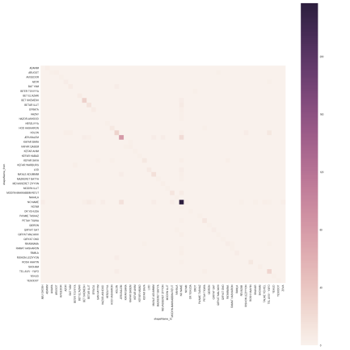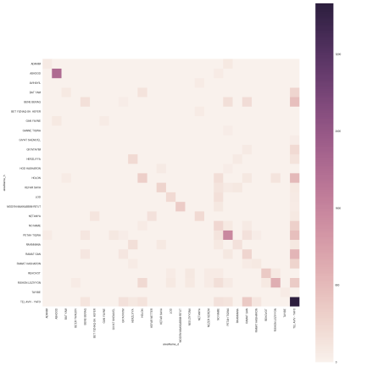

*8.7.12. Heat Map for the transport model (Left) vs. the mobile traces for CTOD 12*

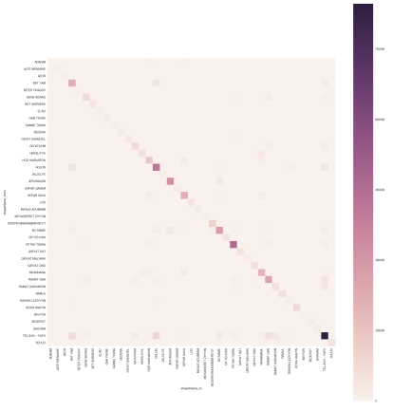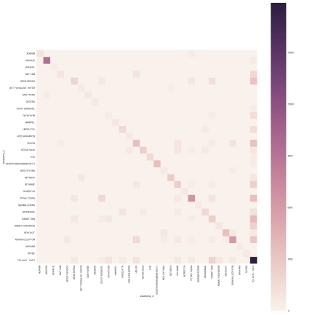

*8.7.13. Heat Map for the transport model (Left) vs. the mobile traces for CTOD 13*

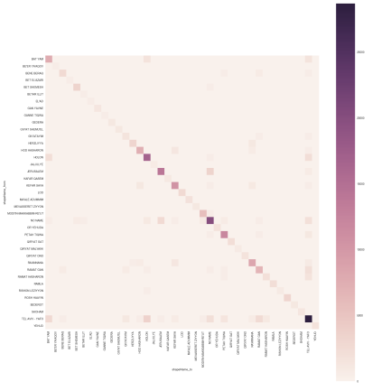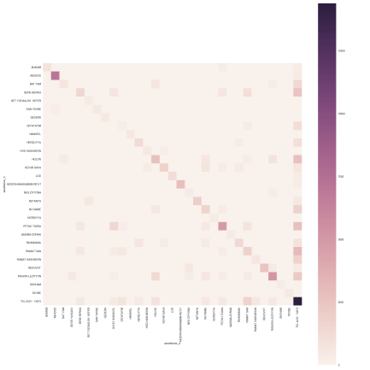

*8.7.14. Heat Map for the transport model (Left) vs. the mobile traces for CTOD 14*

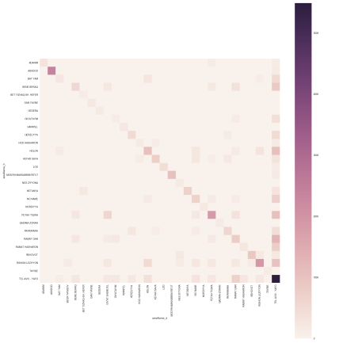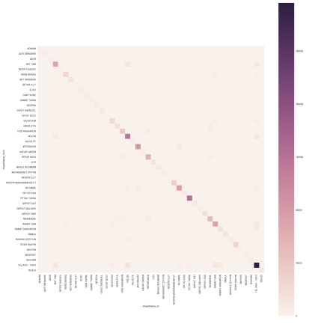

*8.7.15. Heat Map for the transport model (Left) vs. the mobile traces for CTOD 15*

|  |  |  |  |  |  |  |
| --- | --- | --- | --- | --- | --- | --- |
| shapeNamefrom | shapeNameto | % 'Mobile' | % 'Model' | Count 'Mobile' | Count 'Model' | Diff count |
| TEL AVIV - YAFO | TEL AVIV - YAFO | 8.436 | 8.538 | 2729493 | 175645 | 2553848 |
| PETAH TIQWA | PETAH TIQWA | 4.378 | 2.983 | 1416336 | 61360 | 1354976 |
| HOLON | HOLON | 3.928 | 1.293 | 1270803 | 26582 | 1244221 |
| RAMAT GAN | RAMAT GAN | 2.478 | 0.916 | 801727 | 18827 | 782900 |
| KEFAR SAVA | KEFAR SAVA | 2.098 | 0.999 | 678720 | 20541 | 658179 |
| BAT YAM | BAT YAM | 2.061 | 0.284 | 666886 | 5832 | 661054 |
| RA'ANNANA | RA'ANNANA | 1.995 | 0.614 | 645456 | 12624 | 632832 |
| HOD HASHARON | HOD HASHARON | 1.395 | 0.221 | 451170 | 4533 | 446637 |
| MODI'IN-MAKKABBIM-RE'UT | MODI'IN-MAKKABBIM-RE'UT | 1.048 | 1.37 | 339046 | 28175 | 310871 |
| ROSH HAAYIN | ROSH HAAYIN | 0.789 | 0.131 | 255107 | 2680 | 252427 |
| BENE BERAQ | BENE BERAQ | 0.775 | 0.639 | 250518 | 13144 | 237374 |
| TEL AVIV - YAFO | HOLON | 0.653 | 0.469 | 211210 | 9632 | 201578 |
| GIV'ATAYIM | GIV'ATAYIM | 0.63 | 0.15 | 203688 | 3079 | 200609 |
| RAMAT HASHARON | RAMAT HASHARON | 0.605 | 0.29 | 195729 | 5946 | 189783 |
| HOLON | TEL AVIV - YAFO | 0.577 | 1.684 | 186380 | 34635 | 151745 |
| HERZLIYYA | HERZLIYYA | 0.523 | 0.758 | 169138 | 15590 | 153548 |
| RAMLA | RAMLA | 0.513 | 0.135 | 165884 | 2760 | 163124 |
| QIRYAT ONO | QIRYAT ONO | 0.513 | 0.039 | 165679 | 785 | 164894 |
| TEL AVIV - YAFO | RAMAT GAN | 0.483 | 1.217 | 156066 | 25033 | 131033 |
| TEL AVIV - YAFO | BAT YAM | 0.477 | 0.17 | 154265 | 3477 | 150788 |
| RAMAT GAN | TEL AVIV - YAFO | 0.477 | 1.979 | 154089 | 40698 | 113391 |
| LOD | LOD | 0.474 | 0.796 | 153146 | 16365 | 136781 |
| YEHUD | YEHUD | 0.472 | 0.013 | 152550 | 257 | 152293 |
| OR YEHUDA | OR YEHUDA | 0.444 | 0.012 | 143618 | 228 | 143390 |
| HOLON | BAT YAM | 0.431 | 0.225 | 139231 | 4614 | 134617 |
| BAT YAM | TEL AVIV - YAFO | 0.429 | 0.889 | 138726 | 18287 | 120439 |
| BAT YAM | HOLON | 0.415 | 0.437 | 134092 | 8972 | 125120 |
| RAMAT HASHARON | TEL AVIV - YAFO | 0.388 | 1.016 | 125393 | 20894 | 104499 |
| GIV'AT SHEMU'EL | GIV'AT SHEMU'EL | 0.272 | 0.148 | 87970 | 3028 | 84942 |
| TEL AVIV - YAFO | RAMAT HASHARON | 0.267 | 0.348 | 86098 | 7152 | 78946 |
| HOD HASHARON | KEFAR SAVA | 0.254 | 0.187 | 82119 | 3839 | 78280 |
| RA'ANNANA | KEFAR SAVA | 0.248 | 0.289 | 79970 | 5940 | 74030 |
| HERZLIYYA | RA'ANNANA | 0.243 | 0.233 | 78489 | 4773 | 73716 |
| GAN YAVNE | GAN YAVNE | 0.243 | 0.238 | 78486 | 4877 | 73609 |
| GEDERA | GEDERA | 0.235 | 0.221 | 76038 | 4534 | 71504 |

*8.8.1. "diff table" based on area name*

|  |  |  |  |  |  |  |
| --- | --- | --- | --- | --- | --- | --- |
| shapeNamefrom | shapeNameto | % 'Mobile' | % 'Model' | Count 'Mobile' | Count 'Model' | Diff count |
| PETAH TIQWA_834 | PETAH TIQWA_834 | 0.227 | 0.004 | 78668 | 67 | 78601 |
| BET EL'AZARI_552 | BET EL'AZARI_552 | 0.204 | 0.002 | 70624 | 29 | 70595 |
| PETAH TIQWA_830 | PETAH TIQWA_830 | 0.169 | 0.109 | 58440 | 2226 | 56214 |
| RA'ANNANA_2878 | RA'ANNANA_2878 | 0.157 | 0.046 | 54457 | 938 | 53519 |
| PETAH TIQWA_827 | PETAH TIQWA_827 | 0.156 | 0.011 | 53960 | 210 | 53750 |
| BE'ER YA'AQOV_1628 | BE'ER YA'AQOV_1628 | 0.151 | 0.13 | 52180 | 2654 | 49526 |
| TEL AVIV - YAFO_2193 | TEL AVIV - YAFO_2193 | 0.148 | 0.035 | 51172 | 719 | 50453 |
| KEFAR SAVA_2513 | KEFAR SAVA_2513 | 0.144 | 0.024 | 49772 | 482 | 49290 |
| PETAH TIQWA_831 | PETAH TIQWA_831 | 0.136 | 0.003 | 47027 | 61 | 46966 |
| GAN YAVNE_171 | GAN YAVNE_171 | 0.127 | 0.238 | 44000 | 4877 | 39123 |
| PETAH TIQWA_822 | PETAH TIQWA_822 | 0.124 | 0.012 | 42739 | 244 | 42495 |
| TEL AVIV - YAFO_2257 | TEL AVIV - YAFO_2257 | 0.123 | 0.008 | 42438 | 164 | 42274 |
| HOD HASHARON_3025 | HOD HASHARON_3025 | 0.123 | 0.026 | 42390 | 524 | 41866 |
| ADANIM_1561 | ADANIM_1561 | 0.122 | 0.326 | 42110 | 6695 | 35415 |
| RAMAT GAN_2871 | RAMAT GAN_2871 | 0.119 | 0.017 | 41192 | 345 | 40847 |
| JALJULYE_607 | JALJULYE_607 | 0.117 | 0.002 | 40327 | 26 | 40301 |
| QIRYAT ONO_1685 | QIRYAT ONO_1685 | 0.107 | 0.008 | 36971 | 157 | 36814 |
| BAT YAM_2331 | BAT YAM_2331 | 0.102 | 0.014 | 35198 | 280 | 34918 |
| ROSH HAAYIN_841 | ROSH HAAYIN_841 | 0.101 | 0.011 | 34720 | 206 | 34514 |
| SAVYON_575 | SAVYON_575 | 0.097 | 0.036 | 33503 | 740 | 32763 |
| TEL AVIV - YAFO_2210 | TEL AVIV - YAFO_2210 | 0.09 | 0.011 | 31179 | 215 | 30964 |
| PETAH TIQWA_832 | PETAH TIQWA_832 | 0.09 | 0.002 | 31139 | 37 | 31102 |
| GIV'AT SHEMU'EL_738 | GIV'AT SHEMU'EL_738 | 0.088 | 0.002 | 30200 | 21 | 30179 |
| PETAH TIQWA_835 | PETAH TIQWA_835 | 0.082 | 0.013 | 28225 | 263 | 27962 |
| RAMAT HASHARON_847 | RAMAT HASHARON_847 | 0.081 | 0.005 | 28042 | 85 | 27957 |
| RA'ANNANA_2895 | RA'ANNANA_2895 | 0.081 | 0.035 | 27963 | 713 | 27250 |
| KEFAR SAVA_2509 | KEFAR SAVA_2509 | 0.08 | 0.025 | 27455 | 498 | 26957 |
| TEL AVIV - YAFO_2235 | TEL AVIV - YAFO_2235 | 0.078 | 0.027 | 27054 | 537 | 26517 |
| PETAH TIQWA_971 | PETAH TIQWA_971 | 0.071 | 0.002 | 24628 | 31 | 24597 |
| TEL AVIV - YAFO_2191 | TEL AVIV - YAFO_2191 | 0.071 | 0.004 | 24616 | 64 | 24552 |
| HOD HASHARON_3016 | HOD HASHARON_3016 | 0.071 | 0.034 | 24508 | 682 | 23826 |
| HOLON_2477 | HOLON_2477 | 0.071 | 0.01 | 24507 | 186 | 24321 |
| RA'ANNANA_2900 | RA'ANNANA_2900 | 0.071 | 0.001 | 24305 | 3 | 24302 |
| RAMAT HASHARON_850 | RAMAT HASHARON_850 | 0.07 | 0.005 | 24128 | 86 | 24042 |
| GANNE TIQWA_224 | GANNE TIQWA_224 | 0.07 | 0.003 | 23998 | 51 | 23947 |

*8.8.2. "diff table" based on area id*

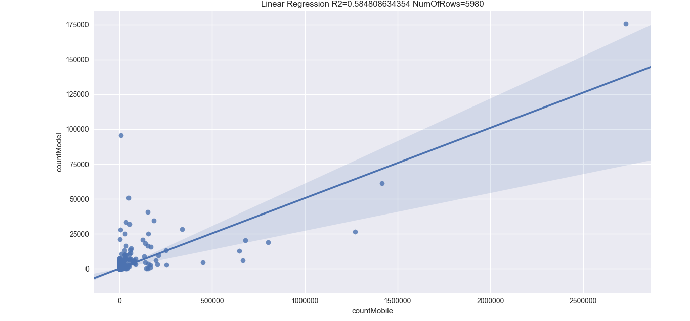

*8.9. Regression analysis 'Model' (Y axis) vs. 'Mobile' (X axis) based on area name*

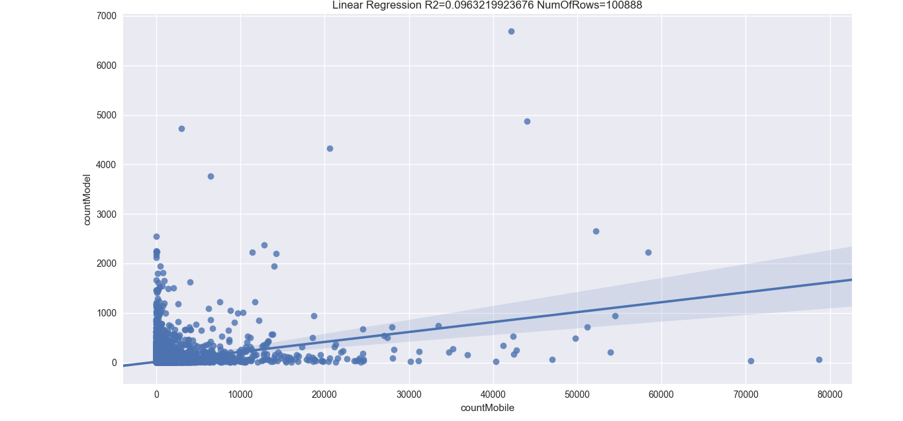

*8.10. Regression analysis 'Model' (Y axis) vs. 'Mobile' (X axis) based on area id*

|  |  |  |
| --- | --- | --- |
| Statistical area ID | Statistical area name | Number of TAZs |
| 127 | TEL AVIV - YAFO | 200 |
| 102 | PETAH TIQWA | 80 |
| 0 |  | 75 |
| 117 | RISHON LEZIYYON | 59 |
| 57 | HOLON | 55 |
| 111 | RAMAT GAN | 47 |
| 4 | ASHDOD | 44 |
| 15 | BENE BERAQ | 39 |
| 90 | NETANYA | 37 |
| 68 | KEFAR SAVA | 35 |
| 54 | HERZLIYYA | 34 |
| 116 | REHOVOT | 32 |
| 110 | RA'ANNANA | 31 |
| 9 | BAT YAM | 27 |
| 112 | RAMAT HASHARON | 26 |
| 55 | HOD HASHARON | 23 |
| 75 | LOD | 23 |
| 47 | GIV'ATAYIM | 21 |
| 1 | ADANIM | 17 |
| 113 | RAMLA | 16 |
| 88 | NES ZIYYONA | 12 |
| 119 | ROSH HAAYIN | 10 |
| 26 | BET YIZHAQ-SH. HEFER | 9 |
| 46 | GIV'AT SHEMU'EL | 9 |
| 60 | KAFAR QASEM | 9 |
| 85 | MODI'IN-MAKKABBIM-RE'UT | 9 |
| 100 | OR YEHUDA | 8 |
| 134 | YAVNE | 8 |
| 5 | AVIHAYIL | 7 |
| 109 | QIRYAT ONO | 7 |
| 130 | TIRE | 7 |
| 34 | GANNE TIQWA | 6 |
| 39 | GEDERA | 6 |
| 126 | TAYIBE | 6 |
| 7 | AZOR | 5 |
| 11 | BE'ER YA'AQOV | 5 |
| 63 | KEFAR HANAGID | 5 |
| 120 | SAVYON | 5 |
| 73 | KEFAR YONA | 4 |
| 78 | MAGSHIMIM | 4 |
| 81 | MIQWE YISRA'EL | 4 |
| 92 | NEZER SERENI | 4 |
| 95 | NIR ZEVI | 4 |
| 136 | YEHUD | 4 |
| 29 | EYAL | 3 |
| 67 | KEFAR NETTER | 3 |
| 69 | KEFAR SHEMARYAHU | 3 |
| 91 | NEWE YAMIN | 3 |
| 105 | QADIMA-ZORAN | 3 |
| 114 | RAMOT HASHAVIM | 3 |
| 118 | RISHPON | 3 |
| 125 | SHOHAM | 3 |
| 132 | YARHIV | 3 |
| 141 | ZOFIT | 3 |
| 3 | AHISAMAKH | 2 |
| 10 | BAZRA | 2 |
| 18 | BENE ZIYYON | 2 |
| 24 | BET OVED | 2 |
| 28 | EVEN YEHUDA | 2 |
| 30 | GAN HAYYIM | 2 |
| 36 | GAT RIMMON | 2 |
| 37 | GE'ALYA | 2 |
| 40 | GELIL YAM | 2 |
| 43 | GIV'AT BRENNER | 2 |
| 44 | GIV'AT HEN | 2 |
| 48 | HADAR AM | 2 |
| 50 | HAFEZ HAYYIM | 2 |
| 59 | JALJULYE | 2 |
| 72 | KEFAR YEDIDYA | 2 |
| 107 | QIDRON | 2 |
| 121 | SEDE WARBURG | 2 |
| 122 | SHA'AR EFRAYIM | 2 |
| 133 | YASHRESH | 2 |
| 139 | ZEMER | 2 |
| 143 | ZUR NATAN | 2 |
| 2 | AHI'EZER | 1 |
| 6 | AZARYA | 1 |
| 8 | AZRI'EL | 1 |
| 12 | BE'EROT YIZHAQ | 1 |
| 13 | BEN SHEMEN(K.NO'AR) | 1 |
| 14 | BENE ATAROT | 1 |
| 16 | BENE DAROM | 1 |
| 17 | BENE DEROR | 1 |
| 19 | BET ARIF | 1 |
| 20 | BET DAGAN | 1 |
| 21 | BET EL'AZARI | 1 |
| 22 | BET HALEWI | 1 |
| 23 | BET HERUT | 1 |
| 25 | BET YEHOSHUA | 1 |
| 27 | ELYAKHIN | 1 |
| 31 | GAN SOREQ | 1 |
| 32 | GAN YAVNE | 1 |
| 33 | GANNE AM | 1 |
| 35 | GANNOT | 1 |
| 38 | GE'ULIM | 1 |
| 41 | GIBBETON | 1 |
| 42 | GIMZO | 1 |
| 45 | GIV'AT SHAPPIRA | 1 |
| 49 | HADERA | 1 |
| 51 | HANNI'EL | 1 |
| 52 | HEREV LE'ET | 1 |
| 53 | HERUT | 1 |
| 56 | HOGLA | 1 |
| 58 | HULDA | 1 |
| 61 | KEFAR AVIV | 1 |
| 62 | KEFAR BILU | 1 |
| 64 | KEFAR HARO'E | 1 |
| 65 | KEFAR HESS | 1 |
| 66 | KEFAR MALAL | 1 |
| 70 | KEFAR SIRKIN | 1 |
| 71 | KEFAR TRUMAN | 1 |
| 74 | LAHAVOT HAVIVA | 1 |
| 76 | MA'AS | 1 |
| 77 | MAGGAL | 1 |
| 79 | MAZKERET BATYA | 1 |
| 80 | MAZOR | 1 |
| 82 | MISHMAR AYYALON | 1 |
| 83 | MISHMAR HASHARON | 1 |
| 84 | MISHMAR HASHIV'A | 1 |
| 86 | NA'AN | 1 |
| 87 | NEHALIM | 1 |
| 89 | NETA'IM | 1 |
| 93 | NIR ELIYYAHU | 1 |
| 94 | NIR GALLIM | 1 |
| 96 | NIZZANE OZ | 1 |
| 97 | NOF AYYALON | 1 |
| 98 | NORDIYYA | 1 |
| 99 | OLESH | 1 |
| 101 | ORANIT | 1 |
| 103 | PETAHYA | 1 |
| 104 | PORAT | 1 |
| 106 | QALANSAWE | 1 |
| 108 | QIRYAT EQRON | 1 |
| 115 | RAMOT ME'IR | 1 |
| 123 | SHEDEMA | 1 |
| 124 | SHEFAYIM | 1 |
| 128 | TEL MOND | 1 |
| 129 | TENUVOT | 1 |
| 131 | YANUV | 1 |
| 135 | YAZIZ | 1 |
| 137 | YESODOT | 1 |
| 138 | ZAFRIYYA | 1 |
| 140 | ZETAN | 1 |
| 142 | ZUR MOSHE | 1 |

*8.11. Mapping TAZs to statistical areas*